Angle Drilling Frame
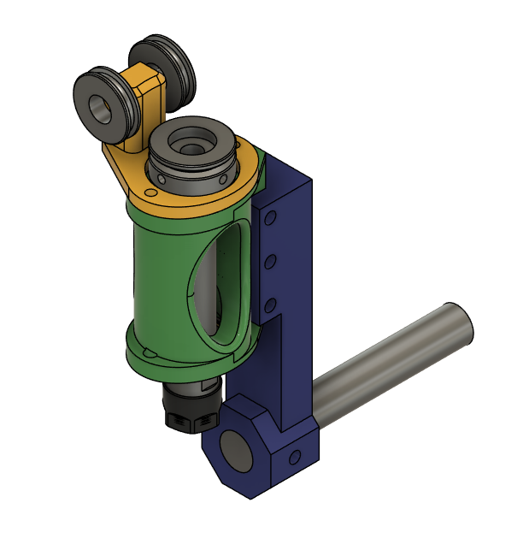

This uses the 3d printed drilling frame in addition to a rotatable arm. It is held in an AXA boring bar holder.
Parts List:
Quantity | Description
4 | 695 Bearing (no flange) used in the idler wheels
2 | M5x10 Shoulder bolt with M4 thread
8 | M5 Heat set insert
2 | M4 Heat set insert
1 | 3/4"x4.125" Steel rod
6 | M5x12 SHCS
1 | AXA holder 250-104
1 | 3d printed drill frame with ER chuck
2 | 3d printed pulleys
1 | 3d printed main arm
1 | 3d printed pulley mount

3d Print Settings:
Setting | Value
Filament | ABS-GF
Walls | 8
Infill % | 40
Infill Pattern | Cubic
Support | Tree Slim
Brim | Outer 15mm

The file, AngleDrillFrame_10mm_Bore.3mf, contains all of the parts for the drill frame housing and the angle drill frame parts for an ER chuck with a 10mm shaft.
The file, AngleDrillFrame_12_and_20mm_Bore.3mf, contains all of the parts for the drill frame housing and the angle drill frame parts for an ER chuck with a 20mm and a 12mm shaft (Only the pulley differs).

